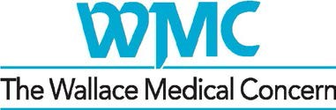

Health “Home Base”
For East County’s Most Vulnerable Accomplishments FY 2017-2018
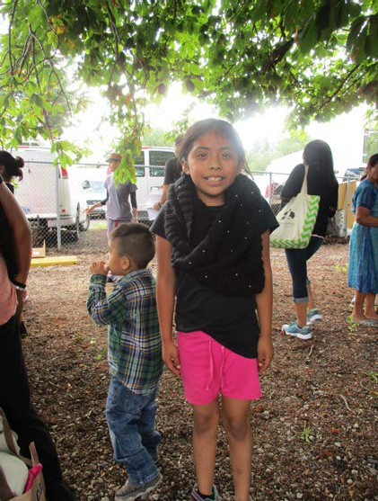Wallace proudly serves a vibrant, culturally diverse, yet economically distressed community. We offer an innovative approach, made specifically relevant for differing populations, that engages families
as leaders in their own care. Our team helps to address cultural, linguistic and financial barriers while offering support and resources to improve health.
Our guiding principle is to meet underserved populations where they are. Wallace has a strong track record of successfully engaging non-English speaking and immigrant families in primary care—and of assisting community members to enroll in health insurance. We emphasize prevention while treating acute and chronic problems, and are always ready to try something creative for each person or family based on their particular needs and circumstances.

Services Tailored to Our Community

Who Are Our Patients?

Wallace serves families in East Multnomah County, including the Rockwood and Gresham communities. We cared for 5,519 people with 19,141 visits last year.
- Our patients are very low income – 90% have incomes at or below the Federal Poverty Level.
- Sixty percent of our patients are people of color.
- We speak in a language other than English in almost half of all visits.
- Many have no health insurance – on average, 35-40%.
o Wallace cares for a far greater proportion of uninsured patients than any other Federally Qualified Health Center in the region (20% average).
Wallace Medical Concern, Accomplishments FY 17-18, Page 1

People in the community we serve face significant barriers to good health:
- According to a 2015 homeless census, at least 3,150 persons who are homeless
live in Wallace’s service area (up from the previous estimate of 2,069).
- Residents living below 100% of the Federal Poverty Level have increased from 14.5% to 22% since 2008.
- Our service area lacks affordable food (healthy or otherwise) sources. At any given time somewhere between 50-65% of Wallace patients self-identify as food insecure.
- The rate of diabetes in our community is over 16%, more than double that in Multnomah County overall.
- Nearly 23% of kids here are obese – compared to the 16% national benchmark.
- Similar statistics related to smoking rates, high blood pressure, cancer screening rates, and child immunizations demonstrate that barriers to health services have been a fact of life for many families for a long time.

One Place for Medical, Dental and More

At Wallace, we want to make it easy for people who face daily practical challenges to find the health and supportive services they need. Our “health home base” offers:

- Comprehensive primary care services, including pediatric, women’s health, preventive care, chronic disease management, behavioral/mental health, immunizations, urgent care and health education.
- Comprehensive dental services integrated with our medical care. We offer most of the dental care that adults and kids need, including lab tests, x-rays and simple surgeries.
- Specialty clinics, classes and support groups for diabetic care.
- On-site access to vision care multiple times per year.
- Enrollment in health insurance, providing access to health care.
- Support services to navigate the regional health system, get special equipment, arrange for transportation and secure resources, such as food and housing, to support good health.
- Health promoting activities such as yoga, Zumba, meditation, and cooking classes.

Getting Connected

Many “hard to reach” individuals and families (homeless, immigrant, refugee and others) in our community do not have a usual source of primary care—and may never have had one.

Wallace Medical Concern, Accomplishments FY 17-18, Page 2

Last year, Wallace expanded outreach efforts that build a bridge to these neighbors and help them connect to our health home base.

Total Care Days of Service
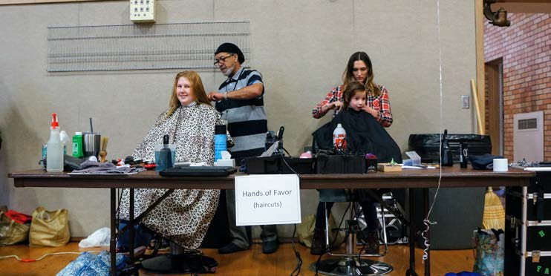These highly enriched events at trusted community locations build rapport with homeless individuals and families. In addition to insurance
enrollment and mobile medical and dental care, participants choose from highly-valued services including haircuts, showers, a variety of health screenings, access to low-cost veterinary care, hot food, free toiletries, oral health supplies and cold weather items— and much more.

Door Knocks

In partnership with our team of students from OHSU’s School of Nursing, we go door-to- door at Home Forward and Human Solutions affordable housing sites in our neighborhood, talking with residents about their health and social service needs, connecting them to our clinic and other community resources, offering basic health screenings, and helping people sign up for Oregon Health Plan insurance on the spot.

Community Events

We met individuals and families at a host of community events throughout the year. Our outreach team provided insurance enrollment assistance and primary care referral at Compassion Connect’s community health events, Rosewood Initiative’s legal expungement days, Neighborhood Night Out, We’ve Got Your Back, and Nadaka Community Festival—just to name a few.

Beyond Exam Room Walls

We know that most of what determines health happens outside of the doctor’s office. It’s realities like substandard housing, or no housing at all. Low wages and unemployment. Few transportation options. Food insecurity. High stress. Trauma.
Unsafe neighborhoods. Language and cultural barriers.

Wallace Medical Concern, Accomplishments FY 17-18, Page 3

Our new strategic plan calls us to dive deep into the “social determinants of health” that impact our patients most. We’re beginning with a focus on housing and food security— linking with others who work on these issues to leverage expertise and resources and develop creative strategies that work for families right here in this community.

Housing for Health

Homeless individuals with multiple medical conditions and mental health needs typically wait months or (more likely) years for housing and/or treatment. The likelihood of being able to secure both is slim. And access to ongoing supportive services – that is a pipe dream. In “Housing for Health”, the dream becomes a reality! Our three-year pilot project will launch and refine a model that combines permanent affordable housing with wrap-around support for a group of WMC’s hardest-to-house patient families.
Thanks to generous funding from the Meyer Memorial Trust, and our partners Home Forward, LifeWorks NW and the Coalition of Community Health Clinics, we have completed our planning phase and look forward to welcoming our first families to their new apartments this fall.

Medical-Legal Project

An outstanding legal issue often poses the last barrier to finding permanent housing. Our new partnership with Kaiser Permanente and Metropolitan Public Defender brings an attorney to our Rockwood site every week. The attorney helps patients to address legal challenges, large and small, that impact their ability to secure a place to live, or remain stable in their housing.

Zenger Farm CSA

Wallace patients enjoyed a weekly box of fresh produce (and recipes!) all summer long when they signed up for our Community Supported Agriculture (CSA) Partnerships for Health program with Zenger Farm. Participants paid just $5 weekly (in cash or SNAP benefits) for a 22-week “prescription” of vegetables and whole grains.

Free Food Market

The “Free Food Market” sets up in the parking lot at our Rockwood clinic on the fourth Tuesday of every month, offering a convenient and healthy free “shopping” opportunity for our patients and neighborhood residents. The market stocks fresh vegetables and fruit as well as pantry staples. Thank you to partners Oregon Food Bank and Human Solutions for joining with us to make this crucial new food resource available.

“We count on Wallace for so much. And there are so many others who count on Wallace. To everyone who helps Wallace, thank you.”

Wallace Medical Concern, Accomplishments FY 17-18, Page 4

